EXPERIMENT-21
21) Implement the Opening technique as a Morphological operation to dilate the foreground regions based on Open CV.

a)CODE
import cv2
import numpy as np
import os

desktop = os.path.join(os.path.expanduser("~"), "Desktop")
img = cv2.imread(os.path.join(desktop, "photo.jpg"))

if img is None:
print("photo.jpg not found on Desktop")
else:
kernel = np.ones((5, 5), np.uint8)
dilation = cv2.dilate(img, kernel, iterations=1)

path = os.path.join(desktop, "dilation.jpg")
cv2.imwrite(path, dilation)

print("Saved at:", path)
cv2.imshow("Dilation Image", dilation)
cv2.waitKey(0)
cv2.destroyAllWindows()

b) INPUT
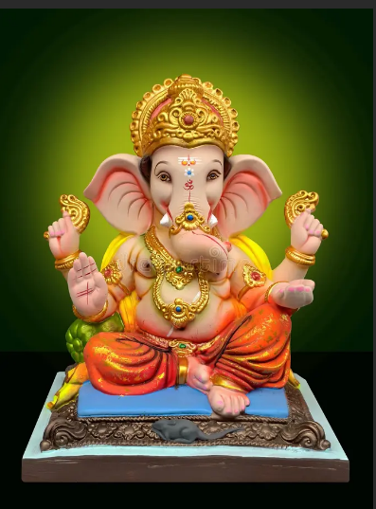

C) OUTPUT
